EFE Road Dust & Survey Responses:

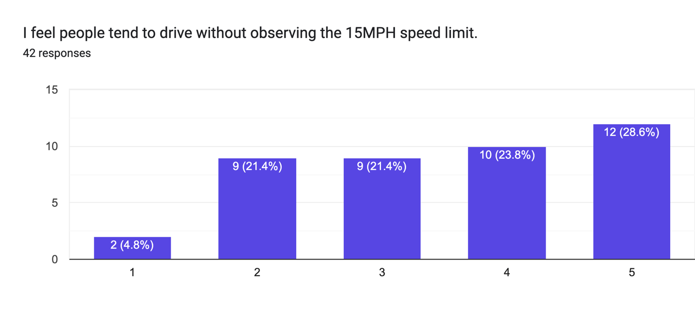
Strongly Disagree Strongly Agree

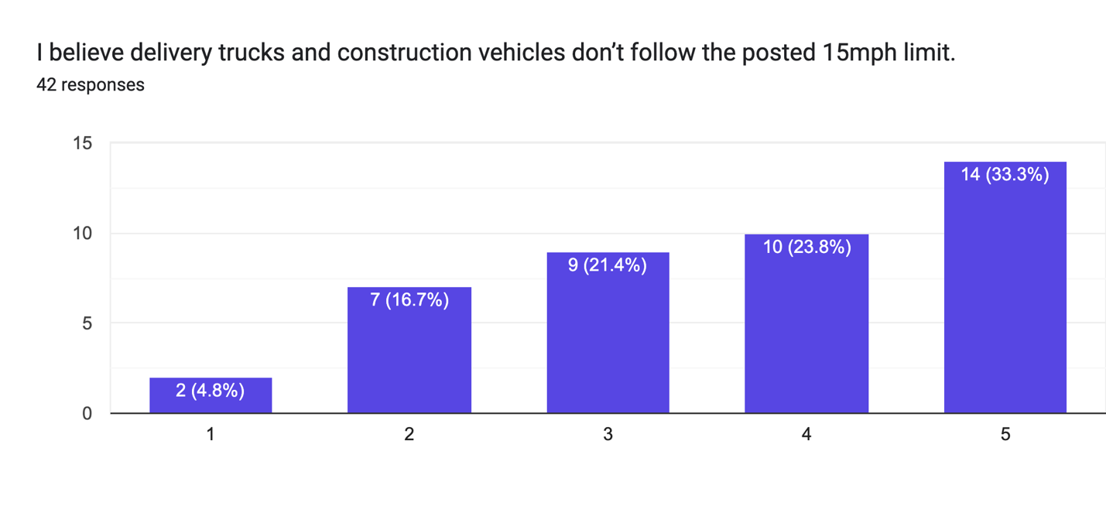
Strongly Disagree Strongly Agree

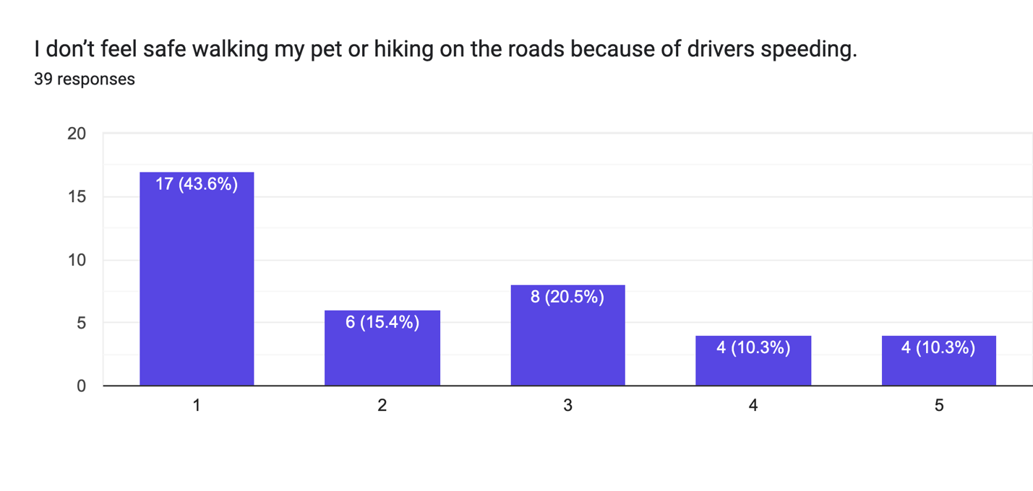Strongly Disagree Strongly Agree

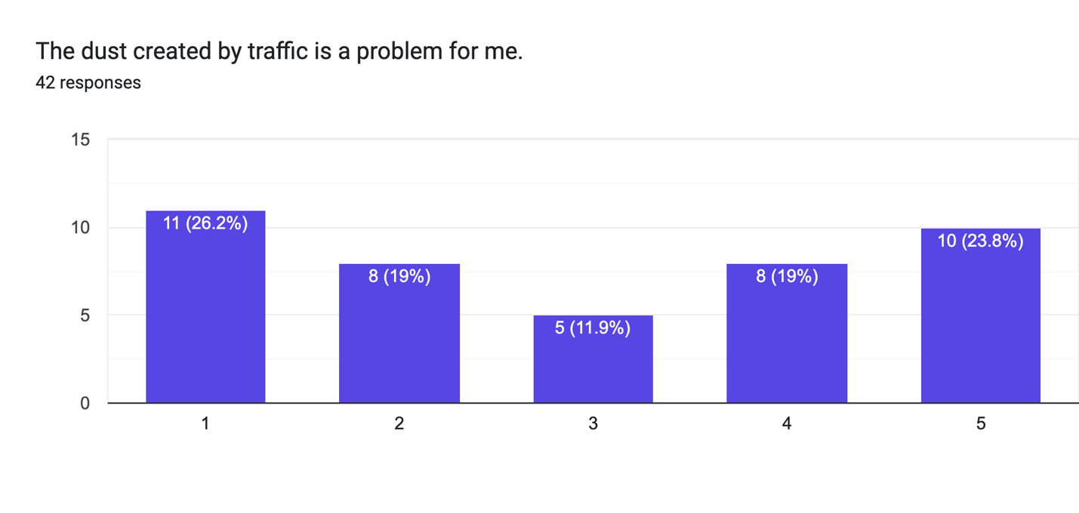
Strongly Disagree Strongly Agree

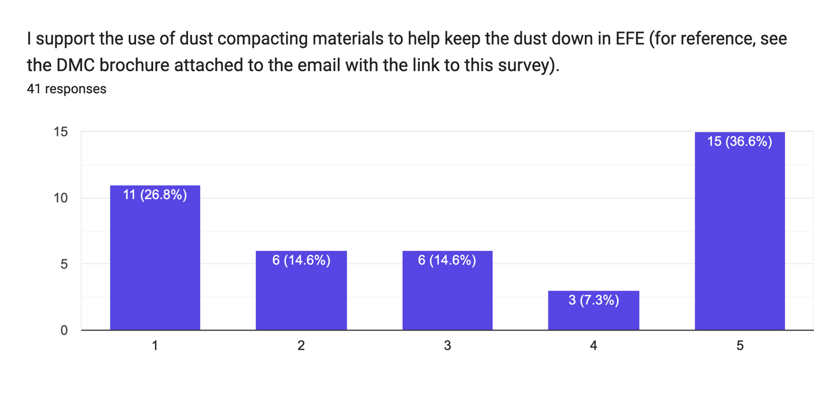
Strongly Disagree Strongly Agree

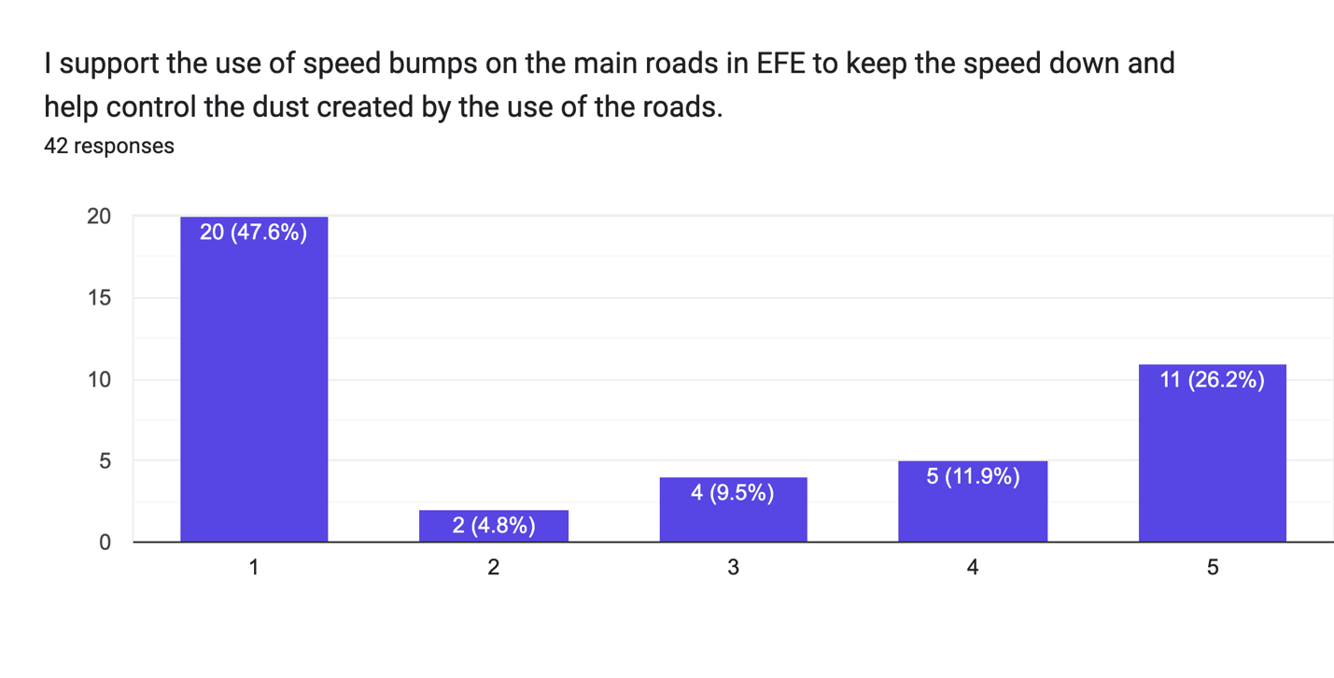
Strongly Disagree Strongly Agree

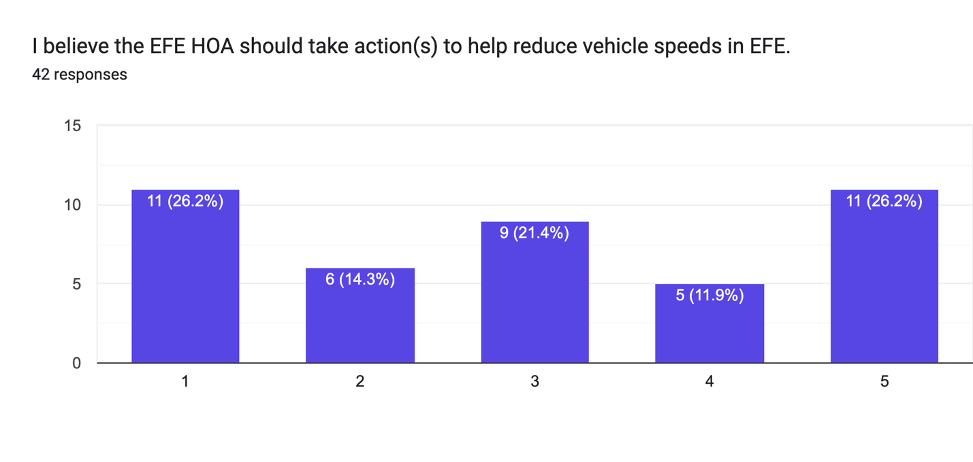
Strongly Disagree Strongly Agree

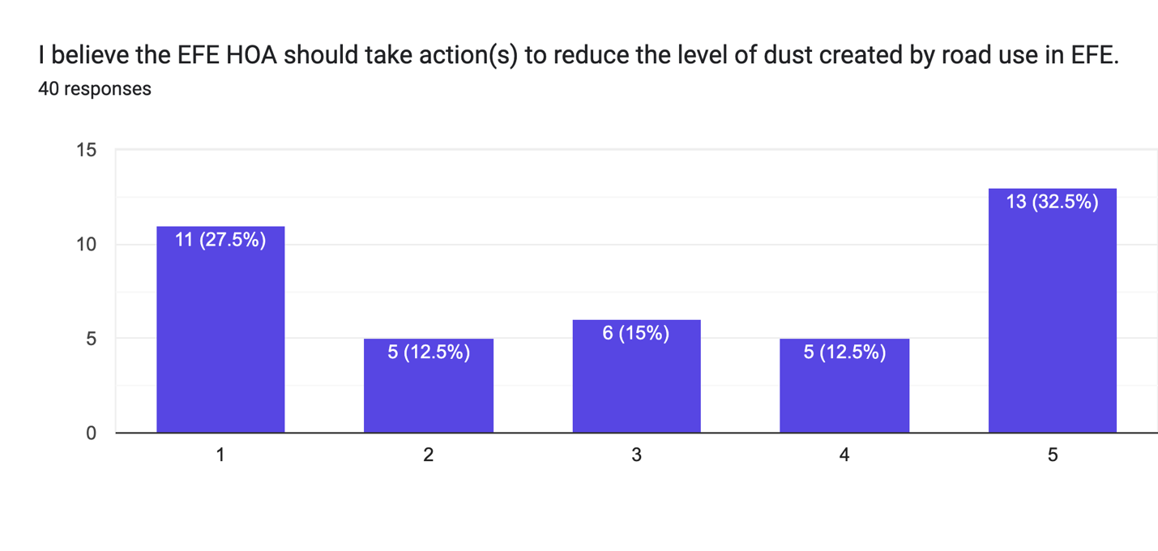
Strongly Disagree Strongly Agree

Comments

- There are a FEW residents who drive too fast. Don’t punish the entire neighborhood for the actions of a few. Dust is a fact of life up here. Especially in the extremely dry conditions we had this summer. Move to the city if you don’t want to deal with the dust. Driving slower definitely helps keep the dust down.

- Kind of vague i.e. what action can EFE take? We could ask sheriffs to patrol the roads. Also I read the brochure and while I think dust control is needed if the roads are not banked properly and repaired the "control" will need to be applied yearly. If you look at Forest Lakes they do their roads every year. We do not have the funds for this. Also need a cost factor for the application. Do not want to see our dues increase because we have to apply this yearly. So more needs to go into this decision. But in general yes many cars are now speeding on the main roads and the dust when they speed is increased. If cars go slow dust is kept to a minimum so maybe speed needs to be addressed first.

- Please NO to Mag Chloride

- I don’t like the idea of chemicals being used to control the dust, would much prefer a different method like speed bumps, signage (stop sign at major intersections), maybe paving in some key areas. I also like the idea of lock boxes at the entrance for UPS and FedEx to keep those vehicles out of the neighborhood.

- There have been some recent breakthroughs in communication with younger drivers who have been speeding on Blue Spruce Drive. A recent personal connection has made a difference, and one particular driver is now obeying the speed limit, at least when passing our house.

- Pot holes and washboards are as problematic as the dust. Posting more 15mph signs would be a good idea.

- Thanks for the survey

- I grew up in the Durango Hills subdivision. It’s quite a bit bigger and people were pretty awful at speeding. The roads were constantly washboardy and bumpy. Every six months, the road crew would come through and grade the roads and add road base and then treat the roads. After that we always used to joke, the roads were perfect for about a week. And then the washboards and the dust were back. The EFE subdivision is considerably smaller, and traffic is less, and the roads are in better condition overall. I think it’s a mistake to spend our money on a road base and treatment that will have to be repeated every year. People who choose to live here do so with the understanding that they will be living near dirt roads - and dirt roads get dusty when the weather gets dry. It’s just a fact of life. I would rather know that the snow will be cleared in the winter, than have perfectly dust free roads. We had a scant snow year last year, but it may be different this year. We need to make sure that we have the funds for snow removal.

- We understand that our household with our young drivers has been a source of concern for some residents from the mailboxes on Enchanted Forest through Blue Spruce Dr. We have shared their concern and worked hard to bring awareness to our drivers of the impact that their speeding has had on their neighbors. We do believe that they have taken responsibility to reduce their speed to within the limit and that they have created a more consistent habit of doing so. We hope that the perception of habitual speeding and lack of safety on the roads, at least to the extent that we can control it, will start to subside as trust begins to rebuild. We will continue to do whatever we can to help rectify this situation within our roads.

- Everyone be an adult and just slow down

- I think speed bumps will cause an issue with the winter plowing. I realize my property is mostly not affected by these issues because at the top of the hill. I don't have an opinion on mag chloride on the road, but is an expense, that might not fix the problem, just give folks an excuse to go faster than 15, because now they are not making dust.

- I would support the EFE purchasing cameras that monitor speed and take photos of offenders. Repeat offenders should be fined. I have two boys ages 1 and 3, when they are old enough to begin playing outside I have great concerns about vehicle speeds on and around the subdivision roads.

- Thank you for your efforts!

- Has it been discussed with the snow removal contractor that we are considering speed bump placement? Will the impact of this effect snow removal capabilities or quotes? I’ve seen smaller vehicles become stuck on speed bumps in the winter time as ice builds; has this also been considered? I would also note that chemical treatments are generally removed in winter with snow, and would need to be reapplied at an unknown rate dependent upon amount removed, traffic etc. I feel that this is a waste of resources and an undo punishment on the majority for the bad actions of a few.

- I am completely against using HOA fees with the dust on the roads. We are a rural community. Drivers will drive faster speeds if the roads have the product to keep dust down. Like in Forest Lakes, for example.

- Remember we live in a mountain setting not in the city with paved streets and sidewalks. Until we all comply with the rules none of the problems will be resolved.

- The cost for dust suppression is extreme. Will simply reduce dust while allowing people to drive as fast as they want regardless but will be able to not create as much dust, does not make a lot of sense to me. I do not want speed bumps on the roads. Perhaps a realistic and cost friendly approach would be to inform the neighborhood of this concern, ask for mindfulness and cooperation, and if it continues to be a problem go from there. Possibly try and identify those who are not mindful. I do know the side by sides, ATV’s, seem to zip around quite a bit. I know I have become more mindful since this issue has been raised, hopefully others as well and we can avoid taking this kind of action. Thank you.

- The Paylors, lot 64 would like to discourage the use of mag chloride dust control on EFE roads as it is a petroleum based product with a heavy chemical scent that will trigger a life threatening, toxic, chemical induced asthma attack for a member of the household. The mag chloride is also very toxic to vegetation, primarily trees, on the downward slopes/drainages of our subdivision roads. An example of the MC impacts to trees can be seen on the south/east side of CR 240 directly across from the Skyline Dr. entrance, due to the shaded nature of the road in the winter, icy conditions and mag chloride applications for de-icing in the winter months over the years. Thank you for allowing resident input around this topic. Please, folks, just SLOW DOWN, respect your neighbors' health and safety and everyone's wellbeing while going easy on neighborhood roads.

