Enchanted Forest Estates (EFE) HOA

Meeting Minutes

December 3, 2023

EFE HOA President, Ken Huls, distributed the NOTICE & AGENDA to all Members, via email, on November 22, 2023.

**AGENDA**

1. Introduction, Attendance, Board Quorum

2. Thank you

3. Welcome New Members

4. Financial Report – Laura Klump, Treasurer

5. Road Maintenance and Repairs Update

6. Committee Reports

a. Road Committee Update - Sean Hembree; Tom Richards

b. Architectural Committee Update - Peggy Lewis; Barb Hembree

c. Community Wildfire Protection Plan (CWPP) Committee Update - Elliott Rice;

Mary Lasser

7. Recess for Special Members Meeting

8. **\* SPECIAL MEMBERS MEETING RE: PROPOSED SPECIAL ASSESSMENT FOR REPAIR**

**OF SOME KNOWN EXISTING ROAD ISSUES - ALL MEMBERS VOTING ITEM \***

a. Introduction and Attendance and Quorum (proxies are included)

b. General Discussion on Proposed Special Assessment

c. Motion and Discussion on the Motion

d. Call for All Members Vote on the Motion, Vote, and Recording of Results

e. Follow-up Planning

f. Adjournment

9. Reconvene Regular HOA Meeting of the Members and Board

10. 03/03/24 Regular Member Meeting Planning

11. Call to the Public: Time permitting, the Board President may at his or her discretion provide an opportunity for Members to bring up brief ideas, thoughts, questions, or concerns regarding topics not on the current meeting agenda but relevant to the EFE Community and its Members. This in not a forum for lengthy discussion but may result in future agenda items.

12. ADJOURNMENT

**1. Introduction, Attendance, Board Quorum**

Ken called the meeting to order at 4:03 PM MST.

Ken noted that there were enough Board Members present for a quorum with the Board and enough Members for a quorum for the Special Assessment vote. Ken reviewed the agenda for today’s meeting. The meeting was conducted via Zoom.

Attendance was taken and the Board Members and Members identified below were present.

**The following EFE Board Members were present:**

Lot 48 - Ken Huls - President

Lot 13 - Elliott Rice - Vice President

Lot 16 - Mike Neith - Secretary

Lot 62 - Mary Lasser - Member at Large

**Other Members present:**

Lot 10 - Sean Hembree

Lot 13 - Amy Smith

Lot 14 - Angela Hugenschmidt

Lot 17 - Sheri McCullogh

Lot 48 - Mica Goldfeder

Lot 50 - Hallie Whitney

Lot 64 - Dan & Amy Paylor

Lot 43 - Lee Verner (joined for Special Members Meeting)

Lot 59 - Sarah Chapman (joined Special Members Meeting)

Ken noted that Laura Klump, the Treasurer, was not present and an attempt was made to contract her. Four of five Board Members were present, so Ken officially declared a quorum.

**2. Thank you**

Ken recognized and thanked Jim for the ditch work he recently completed on upper Skyline. He also thanked Beth and Steve (Lot 56) for using their own equipment to improve the ditches on upper Blue Spruce. Ken recognized and thanked Jimmy for the work he completed near the intersection of Mountain Shadow and Enchanted Forest.

**3. Welcome New Members**

Ken welcomed two new lot owners to the community.

Kelli, Lot 72 and Deirdre, Lot 1

**4. Financial Report – Laura Klump, Treasurer**

With Laura’s absence, Mary agreed to review the financial reports.

Mary displayed the Accounts Receivable Aging Summary Report and explained that this report shows outstanding revenue due from HOA assessments with a Total of $19,005.00. Mary noted that entries showing $350 past due were from Members that chose to pay half in October and half in April and were not really past due. The 15 entries showing $700 or greater are past due. The Board will be discussing the next steps in collecting outstanding dues. Ken stated that it will be an agenda item for the next Board meeting in March.

Mary displayed the Balance Sheet which showed a combined balance of $34,200.74 in the Operating and Money Market accounts with $700 in Undeposited Funds that were recently received.

Mary displayed the Actual vs. Budget - Income and Expense Report

The Actuals column showed $36,875 in Income received, to date, from assessments and $10,865.35 in Expenses paid, to date.

The Budget column showed $52,400 in budgeted Income from assessments and $72,942.74 in budgeted Expenses resulting in a deficit of -$20,542.74.

Ken commented that the $22,200 budgeted under “Known Road Problems” is an estimate that arose from the Road Committee report and is what would be covered by the proposed special assessment, by which then we could start addressing the known road issues.

Mary commented that the regular “Road Maintenance” budgeted amount of $22,500 is what is planned under Justin McCarthy's contract, and it accounts for the regular maintenance that he'll do in the spring and fall. Basically, to pull back all the road material that's been pushed off with the plowing and then in the fall, the grading and smoothing out to make sure that his equipment isn't going to hit anything or get hung up on anything.

Mary also commented that $5,000 was budgeted for “Emergency Road Winter Repairs” based on last year's expenses. The Board felt it was prudent to continue to allocate some money in that bucket on top of regular road maintenance. This allows us to react quickly should we have any of those situations.

**5. Road Maintenance and Repairs Update**

Ken thanked Sean Hembree, Tom Richards, and Mary Lasser for gathering the information in the Road Committee Report that was distributed to all Members on 11/28. Since the report was provided recently, Ken proposed no further discussion was necessary at today’s meeting.

**6. Committee Reports**

**a. Road Committee Update - Sean Hembree; Tom Richards**

Ken asked Sean if there was anything to be added at this time from the Road Committee to the report. Sean responded that nothing to add but he wanted to thank Tom for doing the bulk of the writing. He, Tom, and Mary spent time inspecting the roads on a couple of different occasions but that they are not road engineers and are always open to feedback from the community perspective. He encouraged the Members to always feel free to reach out to he or Tom with questions or input.

**b. Architectural Committee Update - Peggy Lewis; Barb Hembree**

Ken reported that Peggy informed him that there were no new submissions.

**c. Community Wildfire Protection Plan (CWPP) Committee Update - Elliott Rice;**

**Mary Lasser**

Mary commented that she previously sent out a request for fire mitigation hours for Q3 (July, August, September) and that she’s compiled all that data. In early January, she will send another e-mail out for Q4 (October, November, December). Starting in January, Elliott will be taking the lead on this committee. Elliott commented that the next big event is the collecting the Q4 mitigation hours and he'll start collecting that in January.

**7. Recess for Special Members Meeting**

Ken called a recess to the regular meeting at 4:19PM and moved to the Special Members Meeting.

Mike reported that two members joined since the meeting began. Lot 43 – Lee Verner and Lot 59, Sarah Chapman.

8. **\* SPECIAL MEMBERS MEETING RE: PROPOSED SPECIAL ASSESSMENT FOR REPAIR**

**OF SOME KNOWN EXISTING ROAD ISSUES - ALL MEMBERS VOTING ITEM \***

**a. Introduction and Attendance and Quorum (proxies are included)**

Ken asked Mike to confirm both the number of proxy votes and the number in attendance.

Mike reported that there were 13 proxy votes received and there were 11 Members in attendance for a total of 24 lots represented for the vote.

Ken commented that in according to the Covenants and Bylaws, 10% of Members or lots or more are required for a quorum to be declared for purposes of a special assessment. Since the 10% threshold was exceeded, Ken declared a quorum.

**b. General Discussion on Proposed Special Assessment**

Ken offered the Members in attendance an opportunity to make statements with regard to the Special Assessment. There were no statements made by Members in attendance.

**c. Motion and Discussion on the Motion**

Ken stated that he is striking this section because the motion was made at the 10/26 Special Board meeting to prepare and propose a special assessment, which we done, for an All-Member vote.

**d. Call for All Members Vote on the Motion, Vote, and Recording of Results**

Ken called for the All-Member vote on the Special Assessment. Mary conducted the vote, and the results are displayed below.

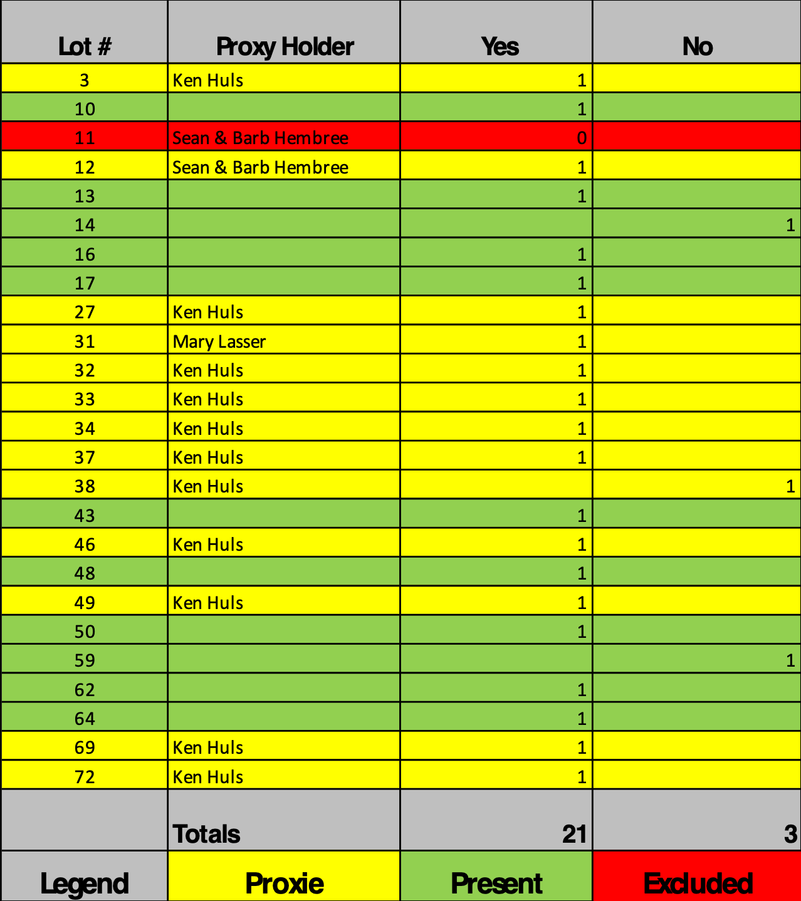

The result of the vote, 21-Yes, 3-No, was confirmed by Mary & Mike.

Mary reported that Lot 11 was excluded from the vote because, in accordance with the Bylaws, they are behind in the assessment and therefore ineligible to vote.

Ken announced that the proposed Specialist Assessment passed by a vote of 21 to 3.

**e. Follow-up Planning**

Ken reported that analysis and bids for the work on upper Blue Spruce and other areas as discussed in the report was in progress. The Road Committee and the Board are expecting to see bids soon from at least one contractor on the upper Blue Spruce problem and as we get more information from more contractors on other issues, the information will be distributed that to all the Members.

**f. Adjournment**

Ken adjourned the Special Members Meeting at 4:30 PM.

**9. Reconvene Regular HOA Meeting of the Members and Board**

Ken reconvened the regular HOA meeting for Members and the Board.

Ken announced the next Regular Member Meeting for March 3rd, 2024.

Ken asked the Board if there was anything else that needed to be addressed.

Mike asked if Ken could distribute the results of the vote along with details on the amount and due date. Ken agreed.

Mary asked Ken “what is the amount of the special assessment and the due date for payment on that that we'll be communicating”? Ken responded that the amount is $300 / Lot and the due date is February 1st, 2024.

Mary agreed and wanted to make note that the date was selected so that the funds are available to start this important work as soon as the snow melts and we can get bids finalized and approved and to get them in to do the work in the spring.

Mary commented that the Board tried to be considerate of the fact that October 1st is the regular assessment, half payment and April 1st is the regular assessment, half payment and then February 1st is kind of in between.

**11. Call to the Public**

Ken opened the floor for comments by all Members.

Hallie commented that her spouse Rob was on the Road Committee years ago, and she is aware of how much time and effort it takes. She wanted to give a shout out to Sean and Tom and the reporting and all the work they did because it's a big job and it affects all of us. So thank you very much.

Elliott added that he wanted to give a special shout out to Ken and Mary and the Road Committee. Great job.

**12. ADJOURNMENT**

Ken announced the next meeting will be March 3rd, 2024 and that he would be sending an email to all Members with regard to the vote and Special Assessment details.

Ken adjourned the meeting at 4:34 PM.